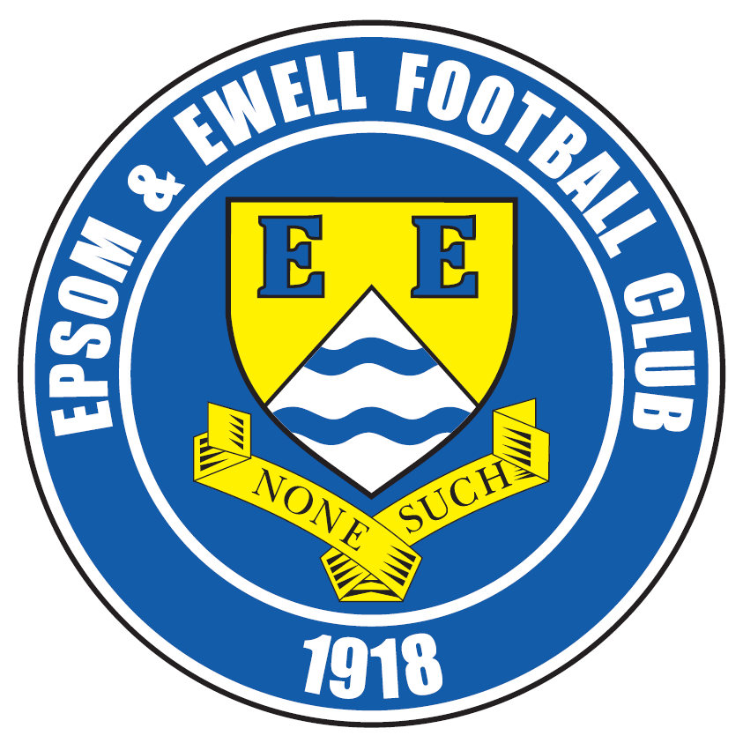 | Epsom & Ewell F.C.  5  v  Raynes Park Vale  Monday, 31st August 2015
Good morning and welcome to High Road for some Bank Holiday football. We welcome the players and officials of Raynes Park Vale, along with today’s match officials and our regular supporters.

Our opponents have started well this season and as usual will present a tough challenge. Both sides won the away fixture in the League last season; Vale were our first visitors last season and won 1-0 last August with a deflected goal, while in the return at Grand Drive in March, goals from Sam Robinson and Kyle Hough secured a 2-0 win that ought to have been three as Kyle had another perfectly legitimate goal chalked off for a handball that didn’t happen. I’m not bitter, honest!!

The last time we were here was for our F.A. Cup exit to Erith & Belvedere. Whilst they were a good side, they came to us on the back of two defeats so it was unfortunate to release any pressure they may have been feeling by conceding after just 19 seconds, and as you all probably know by now went on to win 4-0. I expect them to have beaten Carshalton Athletic on Saturday and be planning for a trip to Corinthian Casuals or Pagham in the next round; another perfectly winnable tie!

Since then we have only had the one match that I can report on, as printing deadlines mean that this issue had to be produced before our trip to Westfield on Saturday. That match was at Sutton United, temporary home of Sutton Common Rovers who currently share their new 3g Astroturf facility, and we won 2-1, although it was nervy at times and we required an 86th minute penalty save from Michael Eacott on his fiftieth appearance to preserve our win.

That said, we probably would have been further ahead if Reisse Griffin hadn’t been blatantly pulled back when running through on goal midway through the second half; an incident missed by nobody except for the three officials. Even the SCR bench were quiet for a few minutes, which is almost unheard of! Luckily it didn’t cost us in the end.

Following today’s match, we next take the field on Sunday when we travel to Horsham YMCA’s ground to play our F.A. Vase match against Horsham. Any replay would be on the Tuesday 8th September and if not, we will host Colliers Wood United instead, so there will definitely be a game; we just don’t yet know who against!

Finally, please note that we will be observing a minute’s silence in respect of those who lost their lives in the tragic plane crash in Shoreham last weekend. This is particularly poignant to clubs like ours, as two of those killed were members of the non-league family who were on their way to play in a match that afternoon. If the proposed F.A. reorganisation that was discussed in 2012 had gone through, we would have been playing both Worthing United and Lancing this season and maybe it would have been our day to travel there. You just never know.

Enjoy the game!

Rich

Check us out on Facebook www.facebook.com/epsomandewellfc or on Twitter @EEFCOfficial

Cover photos by Gemma Jarman

- Mark Jarman puts us ahead against Raynes Park Vale in October 2013

- Our Manager Glyn Mandeville plays against Frimley Green in April 2015


Cherry Red Records
Combined Counties League
Premier Division Table 2015/16
Inc Tuesday 25th August | P | W | D | L | F | A | Pts | GD | H | A
Hartley Wintney | 5 | 5 | 0 | 0 | 27 | 5 | 15 | +22 | 30/1 | 10/10
Hanworth Villa | 4 | 4 | 0 | 0 | 12 | 1 | 12 | +11 | 21/11 | 23/4
Ashford Town (Mx) | 4 | 4 | 0 | 0 | 9 | 3 | 12 | +6 | 30/4 | 24/10
Horley Town | 4 | 3 | 0 | 1 | 9 | 3 | 9 | +6 | 27/2 | 28/12
Raynes Park Vale | 4 | 3 | 0 | 1 | 10 | 5 | 9 | +5 | 31/8 | 28/3
Camberley Town | 4 | 3 | 0 | 1 | 8 | 6 | 9 | +2 | 16/4 | 20/2
Windsor | 5 | 2 | 2 | 1 | 9 | 10 | 8 | -1 | 2-2 | 23/1
Chessington & Hook | 4 | 2 | 1 | 1 | 6 | 4 | 7 | +2 | 7/11 | 19/3
Epsom & Ewell | 3 | 2 | 1 | 0 | 5 | 3 | 7 | +2 | X | X
Westfield | 4 | 2 | 1 | 1 | 5 | 5 | 7 | 0 | 26/3 | 29/8
Colliers Wood United | 3 | 2 | 0 | 1 | 8 | 6 | 6 | +2 | 8/9 | 28/11
Knaphill | 4 | 2 | 0 | 2 | 5 | 5 | 6 | 0 | 12/3 | 14/11
Bedfont Sports | 4 | 1 | 2 | 1 | 6 | 4 | 5 | +2 | 13/2 | 31/10
Farnham Town | 3 | 1 | 1 | 1 | 5 | 3 | 4 | +2 | 26/9 | 6/2
Guildford City | 3 | 1 | 1 | 3 | 3 | 11 | 4 | -8 | 5/12 | 2/4
AFC Hayes | 3 | 1 | 0 | 2 | 2 | 3 | 3 | -1 | 19/9 | 9/1
Sutton Common Rovers | 4 | 0 | 1 | 3 | 6 | 12 | 1 | -6 | 19/12 | 2-1
Chertsey Town | 4 | 0 | 1 | 3 | 1 | 8 | 1 | -7 | 17/10 | 5/3
Spelthorne Sports | 5 | 0 | 1 | 4 | 3 | 11 | 1 | -8 | 16/1 | 12/9
Badshot Lea | 3 | 0 | 0 | 3 | 6 | 12 | 0 | -6 | 9/4 | 12/12
Redhill | 4 | 0 | 0 | 4 | 1 | 9 | 0 | -8 | 2/1 | 1-0
Cove | 5 | 0 | 0 | 5 | 3 | 20 | 0 | -17 | 8/12 | 3/10

Lucky Day? – 31st August
Played 18 - Won 10 Drawn 2 Lost 6 - F 49 A 38 - PPG 1.78 - Good
Club record against Raynes Park Vale (incl Malden Vale)
Played 24 - Won 11 Drawn 5 Lost 8 For 51 Against 35
PPG 1.58 - Above Average
Last visit
Tuesday 5th August 2014 - Lost 0-1 - Combined Counties League

Glyn Mandeville
Good morning everyone and welcome to today's game against Raynes Park Vale.

We have had a good start to the league but played nothing like I know we can play. We had a very disappointing F.A. Cup tie against Erith and Belvedere where we were outplayed and outthought. I take full responsibility over the result and now have put that behind us.

On another disappointing bit of news we lost Agi to Chipstead so we wish him all the best with that ........!!!!


Enough said. I would like to say that our thoughts go out to the families and everyone at Worthing United F.C. who lost the lives of two of their players in the tragic Shoreham air accident last weekend.

Take care, enjoy the game and a safe journey home.

Manders

Sam Currie
Good morning and welcome to High Road for the second home League match of the season.

When we were here last time we had a disappointing defeat in the F.A. Cup - to a good Erith & Belvedere side - however we did not give the game and the occasion a good enough crack and were never really at the races and know the boys will be looking to put this right today.

The league has seen us consistently gain points and we have made a good start, giving ourselves a good platform to work for the season, whilst the new boys have had a chance to bed in now and we are looking to push on from here with a real good togetherness.

I welcome the Raynes Park team today and as always any supporters following them. We know we are in for a tough game today as we have become accustomed to what is usually a well organised side.


I hope you enjoy your afternoon and look forward to hopefully seeing you at High Road once again soon.

Sam

Latest Results and Fixtures
F.A. Cup Extra – Preliminary Round – Saturday 15th August
AFC Hayes | 3-2 | Flackwell Heath
Arundel | 3-1 | Raynes Park Vale
Badshot Lea | 2-1 | Camberley Town
Berkhamsted | 3-2 | Hanworth Villa
Binfield | 1-1 | Westfield
Chessington & Hook United | 1-1 | Crowborough Athletic
Chinnor | 0-2 | Hartley Wintney
Colliers Wood United | 0-2 | Eastbourne Town
Cove | 5-4 | Shrivenham
Croydon | 5-1 | Sutton Common Rovers
Horley Town | 7-0 | Wick & Barnham United
Knaphill | 1-3 | Highworth Town
Potton United | 0-2 | Bedfont Sports
Reading Town | 0-5 | Chertsey Town
Redhill | 1-2 | Pagham
Spelthorne Sports | 2-1 | Stotfold
Tadley Calleva | 2-3 | Guildford City
Wellingborough Town | 1-8 | Ashford Town (Mx)
Windsor | 0-1 | AFC Dunstable
F.A. Cup Extra – Preliminary Round – Sunday 16th August
Epsom & Ewell | 0-4 | Erith & Belvedere
Thame United | 1-1 | Farnham Town
F.A. Cup Extra – Preliminary Round Replays – Tuesday 18th August
Crowborough Athletic | 1-2+ | Chessington & Hook United
Farnham Town | 1-1 | Thame United
Farnham Town won 4-3 on penalties
Westfield | 0-1 | Binfield
Combined Counties League – Tuesday 18th August
Ashford Town (Mx) | 2-1 | Spelthorne Sports
Bedfont Sports | 2-2 | Sutton Common Rovers
Camberley Town | 4-0 | Cove
Chertsey Town | 0-2 | Horley Town
Hanworth Villa | 6-0 | Windsor
Hartley Wintney | 5-0 | Guildford City
Knaphill | 2-1 | Redhill
Combined Counties League – Saturday 22nd August
AFC Hayes | 2-1 | Knaphill
Bedfont Sports | 3-0 | Raynes Park Vale
Chessington & Hook United | 2-0 | Chertsey Town
Colliers Wood United | 1-3 | Hartley Wintney
Latest League and Cup Results and Fixtures
Cove | 2-4 | Ashford Town (Mx)
Guildford City | 1-3 | Westfield
Horley Town | 0-2 | Hanworth Villa
Redhill | 0-1 | Camberley Town
Spelthorne Sports | 0-3 | Farnham Town
Sutton Common Rovers | 1-2 | Epsom & Ewell
Windsor | 2-1 | Badshot Lea
Combined Counties League – Tuesday 25th August
Chessington & Hook United | 3-1 | Spelthorne Sports
Cove | 0-7 | Hartley Wintney
Raynes Park Vale | 2-0 | Guildford City
Westfield | 0-4 | Windsor
F.A. Cup Preliminary Round – Saturday 29th August
Ashford Town (Mx) | V | AFC Kempston Rovers
Badshot Lea | V | Fleet Town
Bedfont & Feltham | V | AFC Hayes
Bedfont Sports | V | Hanwell Town
Chertsey Town | V | Kidlington
Cogenhoe United | V | Spelthorne Sports
Cove | V | North Leigh
Farnham Town | V | Highworth Town
Hartley Wintney | V | Banbury United
Hythe Town | V | Chessington & Hook United
Shoreham | V | Horley Town
Thatcham Town | V | Guildford City
Combined Counties League – Saturday 29th August
Colliers Wood United | V | Redhill
Westfield | V | Epsom & Ewell
Combined Counties League – Monday 31st August
Some matches provisional and dependent on no F.A. Cup replay
Ashford Town (Mx) | prov | Chertsey Town
Bedfont Sports | prov | AFC Hayes
Chessington & Hook United | prov | Colliers Wood United
Epsom & Ewell | V | Raynes Park Vale
Farnham Town | prov | Westfield
Hanworth Villa | prov | Spelthorne Sports
Knaphill | V | Windsor
Redhill | prov | Horley Town
Sutton Common Rovers | prov | Guildford City
F.A. Cup Preliminary Round Replays – Tuesday 1st September
to be advised

From behind the goal
Epsom & Ewell 0-4 Erith & Belvedere
The Emirates F.A. Cup - Extra Preliminary Round - Sunday 16th August 2015

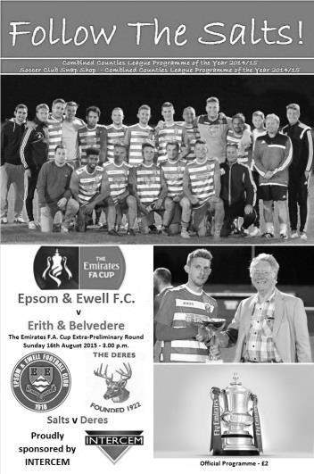
Epsom not at races as Cup dream disappears

The F.A. Cup is a very important competition to clubs at our level. To receive a draw against Erith & Belvedere, F.A. Vase Quarter-Finalists last season was somewhat disappointing as it was one of the toughest pairings we could have faced. However, our decent start to the season, coupled with an indifferent one from our opponents had us believing that we were more than capable of upsetting them on our day. Regrettably we'll never know if that were actually possible as one of our poorest displays in recent years enabled Erith to progress without really breaking sweat.

Changes were made to our starting line-up following our win at Redhill. Matt Farrell was away whilst Craig Hastings and Assistant Manager Matt Smith were both missing due to a wedding that took place the day before. In their places came Dale Marvell and James Taylor, the latter making his first start of the season due to a suspension from last season.

Intriguingly and despite spending the whole of pre-season in defence with Dan Dean in front of him, Dale Marvell started in the holding midfield role alongside Savvas 'Agi' Panayiotou and while both players are excellent with the ball, we were to have great difficulty actually getting the ball from our hosts throughout the entire match.

Unfortunately, we were quite happy to give the ball away too and straight from the kick off we played a blind pass across the centre of the field which was intercepted. Immediately a ball through to the Deres dangerous front man Alfie May into the channel between Matt Tanton and James Taylor ended with him running through at goal and whilst Michael Eacott made a good low save from his powerful strike, the ball fell kindly to his brother Sam who smashed the ball in from close range with just 19 seconds on the clock; our worst start since a home match with Kingsbury Town in January of 1993, when we conceded after just 9 seconds!

Twenty two years ago we were able to get back into that game and would eventually win it, but at no point today did it ever look like that might happen. The visitors were giving us a lot of trouble, particularly on their right where Tanton was getting little support, even after incurring a yellow card midway through the first half and although Eacott didn't have too much to do in the opening forty-five minutes, they still looked

the more likely to score, missing a far post header after 22 minutes before a shot was fired in across the face of our goal three minutes later. We were restricted to long range efforts with both Rob Hendry and Marvell trying their luck from outside the box but without success.

On 35 minutes we had a half chance. Daryl Cooper-Smith was first to reach a misdirected header from the Erith & Belvedere defence and rounded the keeper but was forced very wide as a result and his ball in at goal went straight across their goal no more than three feet out, but with no one gambling on the ball coming across. As the half came to an end, Dean made two clearances; one off the line and another header out from a dangerous cross in before Hendry got away on the left before cutting back and curling his right footed shot just over the bar. We were still in the match, but only just.

Any thoughts of recovery were ended just fifty seconds into the second half. A left wing cross was competed for by our defenders but the ball bounced off one of them and fell kindly for George Mitchell who looped his shot just over Eacott and under the bar. The game was up and everyone in the crowd of 151 knew it.

One thing that we had done so well in our opening games was to close our opposition down and force them into mistakes but this didn't happen at all in this match and this was illustrated when Alfie May rode a couple of half challenges into wide open space and from just over twenty yards fired the ball just inside Eacott's right hand post for their third goal after 53 minutes. It was a great strike but the absence of any real pressure must have helped.

Dean saved us again when the right winger got past Tanton and then cut inside Eacott but a last ditch challenge recovered the situation. We pushed forward in numbers to reduce the deficit but when Cooper-Smith lost the ball in a forward position the counter attack was swift and Alfie May had room on the left and cut in before clipping the ball over Eacott for their fourth goal in the 65th minute.

Our keeper was in action again soon after with a good low save before we had a decent opportunity when their keeper went up with one of our players and the ball dropped to Sam Currie, playing further forward, but his attempt at a lob over the retreating keeper went over the bar. Kyle Hough looped a header towards goal but it lacked power and then Hendry picked up a harsh booking towards the end of the match.

After the fine start to our season, we need to look at ourselves to try to explain how we were able to produce such a flat display in an extremely important game, with only Eacott and the excellent Dean enhancing their reputations by preventing the score from being much higher.

Team: Michael Eacott, Sam Currie ©, Matt Tanton, James Taylor, Dan Dean,
Dale Marvell, Rob Hendry, Savvas 'Agi' Panayiotou, Kyle Hough, Daryl Cooper-Smith, Reisse Griffin

Subs: Rhys North for Cooper-Smith (68)

From behind the goal
Sutton Common Rovers 1-2 Epsom & Ewell
Combined Counties League - Premier Division - Saturday 22nd August 2015

Eacott stars in a tale of two penalties at the Lane

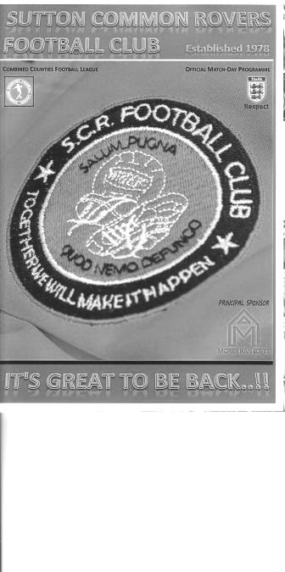
Our young keeper Michael Eacott clearly has a sense of timing. Although it is obviously difficult to save penalties, he waited until the occasion of his fiftieth appearance for the Salts to record his first, with the bonus of earning us three points in the process.

Now the headline is a little misleading, as those who were there will remind me that there was only one penalty in the match, and they'd be correct. However, this match will be remembered mostly for two penalty decisions, one that was awarded and one that wasn't in a game than ran for a hundred minutes and probably felt like even longer to the players on a sweltering hot day at Gander Green Lane, home of Sutton United.

This venue is now also the temporary home for the newly named Sutton Common Rovers, formerly Mole Valley SCR, so on Saturday we travelled to a ground that we last visited in 2008 (when goals from Dale Marvell and Kyle Hough secured a famous Surrey Senior Cup win) and found it much changed. In addition to a new structure at the far end the main change is the conversion from natural grass to a 3g AstroTurf surface and on a hot day the ball held up a bit too much and got under players feet a bit. This made flowing football difficult for both teams.

But for us it was just a matter of getting back to winning ways following our F.A. Cup exit and with Dale Marvell and Dan Dean swapping positions from Sunday's game the only two changes were a return for Matt Farrell and a first appearance for Matt Ferdinando in place of Daryl Cooper-Smith and the recently departed to Chipstead 'Agi' Panayiotou. This gave us more 'bite' in midfield and we were ahead from the first real move of the match in the tenth minute. A mazy weaving run from Kyle Hough enabled him to ride one challenge and evade a couple more before putting Matt Farrell through, but there was still work to do and Farrell showed some nice touches to round the keeper and slot the ball into the empty net.

Three minutes later our Captain Sam Currie timed his overlapping run to perfection and he reached the ball ahead of the keeper, lobbing him from a narrow angle on the edge of the penalty area only to see the ball bounce away off the far post. Two minutes later the hosts had their first opportunity and Eacott was down low to his right to make a fine save. After 21 minutes another run from deep, this time from Hough, stretched the defence and he laid the ball back to Ferdinando who spotted the keeper a little off his line and curled the ball only just over the bar from twenty five yards.

Just before the half hour Hough got away on the left but his powerful shot at goal was blocked by the keeper and a foul by Farrell, during which he was injured enabled both teams to have a quick drinks break. It was a pity that the full time whistle didn't go at that point as I would be able to report on a dominant performance, but the game became more even from

that point and we were never again able to exert as much control.

We really didn't help ourselves either. In the 40th minute Ferdinando was injured and had to come off, but understandably substitute Cooper-Smith wasn't quite ready to come on. However, moments after the game restarted it was obvious that he was ready and with Ferdinando just standing on the side line we were effectively down to ten men. Instead of taking the option of kicking the ball out of play we tried to play with it, finally losing possession and requiring Eacott to make a good save. If we had conceded at that point it would have been criminal. Finally, our man was able to take the field and we played out five minutes of injury time without further incident.

The second half started with a great tackle to win the ball from Cooper-Smith, keen to make the most of his opportunity after having started the previous three matches and he provided a visionary pass over the top to Hough; his low shot requiring a really good save as it arrowed towards the bottom corner.

After 55 minutes I was expecting Hough to get the call as another great ball over the top to Reisse Griffin and he sped through on goal before being firstly pulled back by the shirt and then scythed down by a double combination of defenders, but the penalty was not awarded. How no officials could see when a player is running through, yet suddenly straightens up and slows down, without thinking there was something wrong is beyond me even if they don't actually see the shirt pull, which better positioned officials would have spotted. Fortunately ten minutes later Griffin had his revenge as he struck at goal and although not directed on target Cooper-Smith was able to reach it as it went across goal and he stuck out a leg to divert the ball into the net to double our lead.

It was just as well really, as we had found ourselves doing less of the attacking by this stage and we struggled to cope with the addition of an extra striker in the substitute and former Salt Jay Holden and as two players went up for the ball, it dropped to him from ten yards completely unmarked and he gave Eacott no chance. SCR were back into the game within a minute of being out of it!

We were finding ourselves pushed further back now and Eacott made little contact with the ball when a striker tumbled under the challenge but we were less fortunate in the 86th minute when another player knocked the ball past Marvell, only to realise he'd knocked it too far and so he threw himself into our man and bounced off him theatrically to the ground. Amazingly the referee bought it, but as Holden stepped up to take the penalty Eacott stayed at home and was able to block the fairly central penalty with Matt Tanton able to hack the loose ball clear and with a further six minutes of injury time played for no real reason we were finally able to celebrate the win.

Did we deserve all three points? Well, we were substantially the better side in the first half but the second was one of those that you watch through your fingers at times, and if we had been forced to settle for the draw we could have had no real complaints. However, to have lost points as a result of a farcical penalty decision would have been extremely difficult to take, so Eacott's heroics became the main story today. Just!

Team: Michael Eacott, Sam Currie ©, Matt Tanton, James Taylor, Dale Marvell, Dan Dean,
Matt Ferdinando, Matt Farrell, Kyle Hough, Rob Hendry, Reisse Griffin

Subs: Daryl Cooper-Smith for Ferdinando (44), Conor Davison for Hendry (79),
Tayo Ajayi for Griffin (92)

Club Records - 31st August
Date | Day | Competition |  | Opponents |  | Scorers
31/08/29 | Sat | Friendly | H | Godalming | 6-1 | R.Stimson (3), R.Marlow (2), F.Behn
31/08/32 | Wed | Friendly | A | Sutton United | 3-2 | B.Williams, R.Marlow, o.g.
31/08/35 | Sat | London League Cup 1 | H | Grays Athletic | 4-0 | H.Pullen (3), G.Milnes
31/08/46 | Sat | London League | H | P.O.Engineers | 5-1 | D.Ralph (4), K.Holliday
31/08/57 | Sat | Corinthian League | A | Grays Athletic | 2-2 | J.Bangs (2)
31/08/60 | Wed | Corinthian League | H | Uxbridge | 2-3 | F.Whitehouse, D.Wells
31/08/63 | Sat | Athenian League 1 | A | Uxbridge | 2-3 | J.O'Shea, R.McNicol (pen)
31/08/68 | Sat | Athenian League 2 | A | Horsham | 1-2 | T.Seymour
31/08/70 | Mon | Athenian League 2 | A | Wingate | 0-5
31/08/74 | Sat | Surrey Senior League | A | Virginia Water | 3-1 | J.Eales, D.Ritman, C.Rose
31/08/77 | Wed | Isthmian League 2 | H | Molesey | 4-2 | G.Butler, R.Parkin, S.Delaney, T.Tuite
31/08/81 | Mon | Isthmian League Cup 1 | H | Aveley | 2-1 | J.Hunn (pen), M.Francis
31/08/85 | Sat | Isthmian League  Premier Division | H | Hendon | 5-3 | M.Sorensen, C.Miles, T.Tuite, R.Lewis, D.Hanks
31/08/91 | Sat | F.A. Cup Preliminary Round | H | Walton & Hersham | 1-5 | T.Tweedy
31/08/96 | Sat | F.A. Cup Preliminary Round | A | Burgess Hill Town | 1-4 | P.Meredith
31/08/99 | Tue | Isthmian League Cup Preliminary Round | A | Clapton | 4-0 | S.Hatton (2), S.Miller, J.Hall
31/08/02 | Sat | F.A. Cup Preliminary Round | A | Corinthian Casuals | 1-1 | S.Huckle
31/08/13 | Sat | Combined Counties  Premier Division | A | Ash United | 3-2 | K.Hough (2), R.Burns
Historical Decades
Date | Day | Competition |  | Opponents |  | Scorers
90 years ago – Epsom Town F.C.
05/09/25 | Sat | Friendly | H | Kingstonian | 2-2 | R.Marlow, J.Parr
80 years ago – Epsom F.C.
31/08/35 | Sat | London League Cup 1 | H | Grays Athletic | 4-0 | H.Pullen (3), G.Milnes
60 years ago – Epsom F.C.
27/08/55 | Sat | Corinthian League | H | Grays Athletic | 2-0 | D.Hermitage, R.Colfar
50 years ago – Epsom & Ewell F.C.
30/08/65 | Mon | Athenian League Div 2 Cup 1 | A | Lewes | 0-0
40 years ago – Epsom & Ewell F.C.
30/08/75 | Sat | F.A. Cup Preliminary Round | H | Corinthian Casuals | 4-2 | D.Worby, T.Tuite, T.Algar, T.Lee
30 years ago – Epsom & Ewell F.C.
31/08/85 | Sat | Isthmian League Premier Division | H | Hendon | 5-3 | M.Sorensen, C.Miles, T.Tuite, R.Lewis, D.Hanks
20 years ago – Epsom & Ewell F.C.
25/08/95 | Fri | F.A. Cup Preliminary Round | H | Tooting & Mitcham United | 0-4
10 years ago – Epsom & Ewell F.C.
28/08/05 | Sun | F.A. Cup Preliminary Round | H | AFC Newbury | 6-1 | J.Goodwin (2), L.Jones, R.Ingham, A.Stones, C.Read

History Corner – 31st August
90 years ago this week we played our very first match at West Street!!

After a few seasons at Alexandra Recreation Ground and a few more at the Horton Hospital Sports Ground we were finally able to move into a private ground in Ewell Village and celebrated by inviting Kingstonian over for a Friendly challenge match on Saturday 5th September 1925.

We took the lead through our great striker Reg Marlow, although the more experienced side fought back to lead 2-1. We weren’t finished though and Jack Parr was able to score an equaliser on a very wet day. The West Street era had begun!

86 years ago today we opened up our season with a visit from Godalming and a hat trick from Reg Stimson helped us on our way to a 6-1 friendly win. Although it was the start of the season this wasn’t a pre-season friendly of the kind we know today, this was an official challenge match and was very much a part of the club’s records.

80 years ago this week Jackie Pullen scored a hat trick for Epsom as we crushed Grays Athletic 4-0 in the first round of the London League Cup.

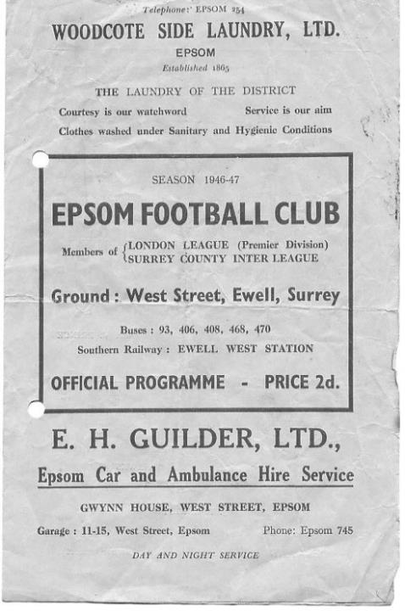
69 years ago today we defeated the Post Office Engineers 5-1 in a London League match at West Street. (see programme) The highlight of the match was four goals from Don Ralph, who remains the only person to have scored four times for our club on his debut.

30 years ago today we reached the highest point in our entire history, but it didn’t look like it would happen at all. In our second season in the Isthmian League Premier Division, we had started off with a 2-2 at Walthamstow Avenue and a narrow 1-0 win over Bognor Regis Town. Our next match was against Hendon and things didn’t start well at all as we trailed 3-0 after just 38 minutes. However, we had reduced the deficit to 2-3 by half time and we were 4-3 up just after the hour mark, scoring a fifth goal to seal the win on the final whistle.

The win placed us in second position in the admittedly early League table, and when leaders Yeovil Town crashed 4-1 at Croydon on the Monday, we would get a chance to go top if only we could beat Dulwich Hamlet the next evening. Unfortunately we were defeated 3-0 and ended up being relegated that season and the next. This day was very much the high water mark for our club in terms of League achievement. It doesn’t seem like thirty years ago though!

20 years ago this week Tooting & Mitcham United visited Merland Rise and beat us 4-0, which was not surprising as they were a couple of divisions above us. However, the story here is that due to landlords Banstead Athletic being at home on the Saturday, this match was brought forward a day and we thus became the first team out of the F.A. Cup that season!

10 years ago this week we beat AFC Newbury 6-1 in the F.A. Cup. They were a newly formed team, created in the ashes of the old Newbury Town but we had far too much for them. It was a personal triumph for Jamie Goodwin who scored twice for us and remains the last person to score two goals on his debut for us.

Centre page for results

Centre page for results



Raynes Park Vale F.C. – History
Raynes Park Vale FC was founded in 1995 from the merger of two clubs, Raynes Park FC and Malden Vale FC.

Raynes Park FC was founded in 1964, taking over from the Southern Railway Football Section. These details were confirmed by our current President, Robert Hallett Snr. who was instrumental in the formation of the club.


From these humble beginnings, the club ran five senior teams on Saturdays. The 1st & 2nd XI's played out of the Surrey Premier League. The 3rd team played in the Surrey South Eastern Counties League, whilst the 4th & 5th teams played in the Kingston & District. Raynes Park also had an over 35's team who played their matches on Sundays and also ran teams from under 14's to under 18's.

Malden Vale FC was founded in 1967 by the then Chairman Stephen Pearce. They spent their first decade of existence playing in the North Surrey Youth League, the Sunday Sportsman League, South Thameside League & the Surrey Combination League. Malden Vale won a total of 37 honours at junior & intermediate level.

Malden Vale gained senior status in the 1977-78 season and were duly elected to the Surrey Senior League. The following season the league changed its name to the Home Counties League. After one season in the newly named league, Malden Vale applied to join the London Spartan League. They were accepted into the Premier Division. Ten seasons later in the 1988-89 season Malden Vale finished runners-up to BAE Weybridge in the Dan Air League and were promoted to the Diadora League Division 2 South. All of the club's members worked extremely hard to gain C Grade status for entry into the league.

The club survived for 5 seasons in the Diadora Isthmian League. At the end of the successful 1993-94 season, managers Mick Brown & Ged Murphy left the club to join Hendon. Unfortunately many of the players followed them and Malden Vale finished bottom of the table the following season.

On Saturday 18th August 1995, after two years in the planning, the newly formed Raynes Park Vale FC played its first match in the Combined Counties League.

In 2013 the club was granted £50,000 from the Budweiser Club Futures Programme, by the FA, towards the cost of ground and club/function room upgrade, which was completed in 2014.

In 2014/15 we finished in 15th position after a strong start, which also included a run to the second qualifying round of the F.A. Cup, losing narrowly at Ryman Premier League team Billericay Town.

Match and Ball Sponsorships – 2015/16
Opponent | Date | Match Sponsor | Ball Sponsor
Hoddesdon Town | 18/07/15 | Geoff Dyke
Windsor | 08/08/15 | Club President Stella Lamont
Erith & Belvedere | 16/08/15 | Mike Lovett
Raynes Park Vale | 31/08/15 | EEFC Management Committee
Colliers Wood United | 08/09/15 | Assuming no Vase replays for either team
AFC Hayes | 19/09/15
Farnham Town | 26/09/15
Chertsey Town | 17/10/15
Dorking Wanderers | 20/10/15 | Surrey Senior Cup
Chessington & Hook United | 07/11/15
Hanworth Villa | 21/11/15
Guildford City | 05/12/15
Cove | 08/12/15
Sutton Common Rovers | 19/12/15
Redhill | 02/01/16
Spelthorne Sports | 16/01/16
Hartley Wintney | 30/01/16
Bedfont Sports | 13/02/16
Horley Town | 27/02/16
Knaphill | 12/03/16
Westfield | 26/03/16
Badshot Lea | 09/04/16
Camberley Town | 16/04/16
Ashford Town (Mx) | 30/04/16
For League, League Cup and Surrey Senior Cup Matches:
Match sponsorship - £40.00 Match ball sponsorship - £25.00. Combined £55.00.
For F.A. Cup and F.A. Vase matches:
Match sponsorship - £50.00 Match ball sponsorship - £30.00. Combined £65.00.

Sponsorship includes: (x2 for match, x3 for match and ball)

Admission, programmes, hospitality and advertising and mascot for the day (if required).
If you are interested, just speak to a Committee Member, or drop me an email at: richard.c.lambert@gmail.com


We also thank our Kit Sponsors INTERCEM

Player Sponsorship
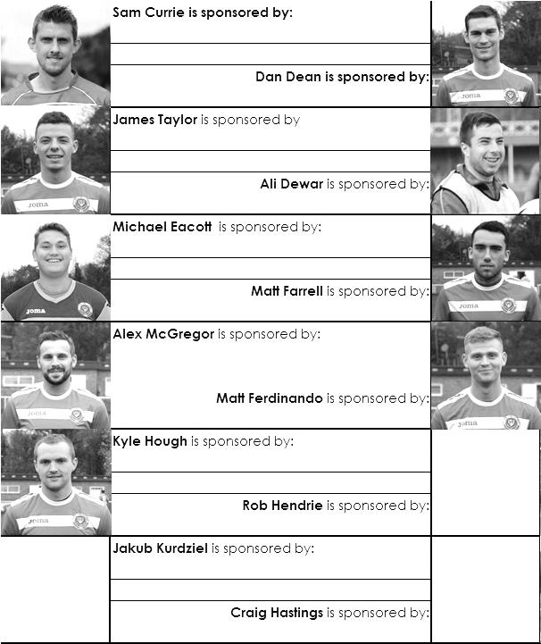

Here is the current list for the 2015/16 season showing all of our players and Management that are currently available for sponsorship this season. Pictures for our new players will feature shortly as will an updated list.

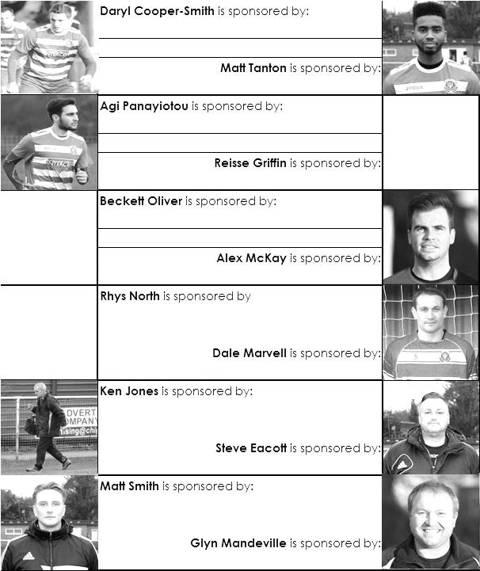
Sponsorship costs just £40 and it is easy to do. Just select a player who has not been previously sponsored and let a Committee Member know that you would like to sponsor them. Beware though. Until we have received the money it is possible for someone to jump in front of you, so don’t delay, sponsor today!

First Eleven Appearances - (max 4 – including SCR match – 22/08/15)
Name | Debut | 2014/15 |  |  |  | Career Totals
Name | Debut | App | Sub | Total | Goals | App | Sub | Total | Goals
AJAYI Tayo | 22/08/2015 | 0 | 1 | 1 | 0 | 0 | 1 | 1 | 0
COOPER-SMITH Daryl | 03/01/2015 | 3 | 1 | 4 | 1 | 12 | 4 | 16 | 7
CURRIE Sam | 04/08/2012 | 4 | 0 | 4 | 0 | 112 | 9 | 121 | 2
DAVISON Conor | 22/08/2015 | 0 | 1 | 1 | 0 | 0 | 1 | 1 | 0
DEAN Dan | 02/08/2014 | 4 | 0 | 4 | 0 | 40 | 1 | 41 | 0
DEWAR Ali | 29/10/2011 |  |  |  |  | 55 | 35 | 90 | 10
EACOTT Michael | 02/08/2014 | 4 | 0 | 4 | 0 | 50 | 0 | 50 | 0
FARRELL Matt | 02/08/2014 | 3 | 0 | 3 | 1 | 44 | 3 | 47 | 8
FERDINANDO Matt | 20/09/2014 | 1 | 0 | 1 | 0 | 28 | 4 | 32 | 6
GRIFFIN Reisse | 08/08/2015 | 4 | 0 | 4 | 0 | 4 | 0 | 4 | 0
HASTINGS Craig | 08/08/2015 | 2 | 0 | 2 | 0 | 2 | 0 | 2 | 0
HENDRY Rob | 08/08/2015 | 4 | 0 | 4 | 1 | 4 | 0 | 4 | 1
HOUGH Kyle | 14/08/2007 | 4 | 0 | 4 | 2 | 300 | 15 | 315 | 173
MARVELL Dale | 15/01/2000 | 3 | 0 | 3 | 0 | 264 | 45 | 309 | 85
MCGREGOR Alex | 08/08/2009 | 0 | 1 | 1 | 0 | 172 | 57 | 229 | 27
MCKAY Alex | 20/12/2008 |  |  |  |  | 85 | 26 | 111 | 8
NORTH Rhys | 16/08/2015 | 0 | 1 | 1 | 0 | 0 | 1 | 1 | 0
OLIVER Beckett |  | 0 | 0 | 0 | 0 | 0 | 0 | 0 | 0
PANAYIOUTOU Savvas | 03/01/2015 | 2 | 0 | 2 | 0 | 18 | 3 | 21 | 3
SMITH Matt | 08/08/2009 |  |  |  |  | 91 | 43 | 134 | 10
TANTON Matt | 02/08/2014 | 4 | 0 | 4 | 0 | 22 | 4 | 26 | 1
TAYLOR James | 26/08/2013 | 2 | 0 | 2 | 0 | 58 | 8 | 66 | 3

Scouting the Opponent – Horsham F.C.
Next Sunday we visit Horsham in the F.A. Vase; a team that have a similar story to ourselves.

It has been a few years now since they lost their famous ground at Queen Street to developers and like us, there have been a few problems encountered in their battle to obtain a new ground back in the town. Although they are now back in Horsham, courtesy of near neighbours Horsham YMCA, where we travel for this match, this has now led to problems on the pitch and they find themselves back at Step Five football, following their relegation from the Ryman League in April.

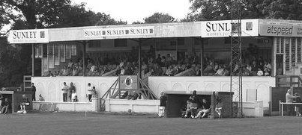
They are still a well-supported team and we face a difficult challenge as they are top of the table as I write, having beaten last season’s Champions Littlehampton Town by five goals to one on Wednesday. Just for old time’s sake, here is a picture of their old stand.

Southern Combination League – Premier Division
Including Weds 26th August | P | W | D | L | F | A | Pts | GD
Horsham | 4 | 3 | 1 | 0 | 14 | 2 | 10 | +12
Horsham YMCA | 4 | 3 | 1 | 0 | 15 | 5 | 10 | +10
Newhaven | 4 | 3 | 1 | 0 | 12 | 2 | 10 | +10
Pagham | 4 | 3 | 1 | 0 | 13 | 4 | 10 | +9
Eastbourne Town | 4 | 3 | 1 | 0 | 10 | 2 | 10 | +8
Lancing | 3 | 3 | 0 | 0 | 11 | 3 | 9 | +8
Littlehampton Town | 4 | 2 | 0 | 2 | 15 | 13 | 6 | +2
Hassocks | 3 | 1 | 2 | 0 | 4 | 3 | 5 | +1
Chichester City | 4 | 1 | 2 | 1 | 11 | 11 | 5 | 0
Arundel | 3 | 1 | 1 | 1 | 5 | 4 | 4 | +1
AFC Uckfield Town | 4 | 1 | 1 | 2 | 8 | 8 | 4 | 0
Loxwood | 3 | 1 | 1 | 1 | 6 | 7 | 4 | -1
Worthing United | 2 | 1 | 0 | 1 | 6 | 9 | 3 | -3
Broadbridge Heath | 4 | 1 | 0 | 3 | 4 | 9 | 3 | -5
Eastbourne United Association | 3 | 0 | 2 | 1 | 3 | 5 | 2 | -2
Hailsham Town | 3 | 0 | 1 | 2 | 4 | 8 | 1 | -4
Shoreham | 3 | 0 | 1 | 2 | 2 | 8 | 1 | -6
East Preston | 4 | 0 | 0 | 4 | 8 | 13 | 0 | -5
Wick & Barnham United | 3 | 0 | 0 | 3 | 1 | 10 | 0 | -9
St Francis Rangers | 4 | 0 | 0 | 4 | 0 | 26 | 0 | -26

Player Profile – Number 2 – Dan Dean
Dan Dean our Vice-Captain is the next player to complete his profile for us.


He joined us at the start of last season from Chipstead, making his debut on opening day in the 2-0 win at Farnham Town.

Age: 25

Previous Clubs: Fulham, AFC Wimbledon, Leatherhead Walton & Hersham, Merstham, Chipstead

Position: Centre back / centre midfield / behind the striker

Club supported: Chelsea

Favourite Food: Mexican

Favourite Film: Toy Story 3 (sing along)

Messi or Ronaldo: Ferdi (Matt Ferdinando!)

Favourite Drink: Fosters

Best moment for the club to date: Captaining the team to three back to back wins

Describe the Gaffa in three words: The – Ginger – Ninja

Dan’s Playing Stats: Debut 02/08/14 - Total Appearances: 41 - Total Goals: 0
Win Ratio (the amount of games he has played in that we have won) 48.65%

Congratulations Michael!
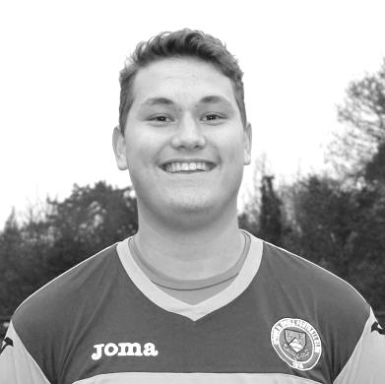
Congratulations go to our young keeper Michael Eacott who made his 50th appearance for the club in our 2-1 win at Sutton Common Rovers on Saturday 22nd August, crucially saving a penalty four minutes from time.

As with Dan Dean above, he made his debut on the opening day of last season having joined us from Colliers Wood United.

He is the 257th player to reach this mark, which might sound a lot, but we have had over 1,500 players over 91 years of senior existence, so it is still quite an achievement!

Hopefully he will be around to make many more appearances for us, although not today, as he is both unavailable and injured!

Salts Super Six Predictor
The Salts Super Six Predictor is live again today and the tickets are on sale at today’s game to the left of the gate. We have taken a dip into the Conference National today and all of these matches are to be played this afternoon.

The competition is easy to play! To win, you simply need to predict the results of six matches correctly from the three options, fill in the form and make sure it is back with one of our distributors before the deadline on the ticket.

If you are a club regular, you just need to place your name on the sheet, although if you aren’t, then we’ll need a contact number from you too. We will announce any winners on the website within three working days, so don’t worry, we won’t miss you!

We had a big jackpot winner last year and who knows how much could be won this time! It is currently £133 and you’ll always know the size of the pot before you enter.

Please note that if there is more than one winner, the prize pot would be shared between the winners. All you need to do now is have a go, as many times as you like!

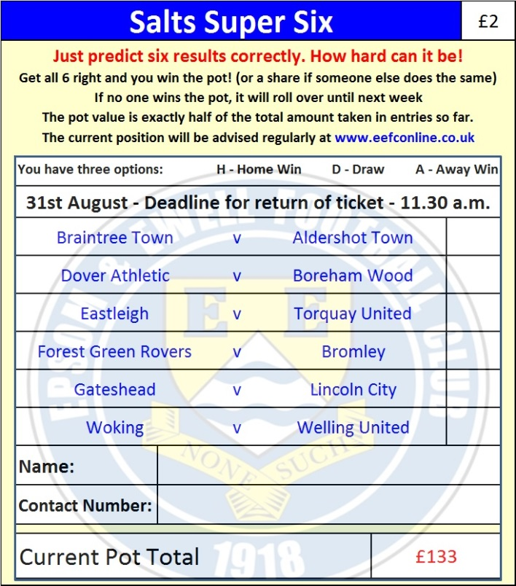

Good luck!

Combined Counties League – Premier Division
Tuesday, 31st August 2015 - Kick-off 11.30 a.m.
Epsom and Ewell  (Royal Blue & White hoops) | V |  | Raynes Park Vale  (All Yellow)
Squad | NUMBERS
Michael Eacott |  |  | Bala Ardit
© Sam Currie |  |  | Leithan Brimah
Matt Tanton |  |  | Thomas Cowan
Dale Marvell |  |  | Marcus Dowdeswell
James Taylor |  |  | Sam Filler
Dan Dean |  |  | Calum Forbes
Matt Farrell |  |  | Jack Gray
Reisse Griffin |  |  | Callum Hart
Kyle Hough |  |  | Dariush Heravi
Daryl Cooper-Smith |  |  | Shane McEntaggart
Matt Ferdinando |  |  | Ashley Merchant
Rob Hendry |  |  | Simon Moore
Conor Davison |  |  | Antony Moulds
Jakub Kurdziel |  |  | Victor Okunaoo
Rhys North |  |  | Marlon Perrin
Tayo Ajayi |  |  | Paul Roberts
Alex McKay |  |  | Jerome Smart
Craig Hastings |  |  | Conor Turner
Alex McGregor |  |  | Reece Turner
Glyn Mandeville | MANAGER |  | Gavin Bolger
Matt Smith | ASSISTANT |  | Paul Bentley
Steve Eacott / Alex McKay / Ken Jones | COACHES / PHYSIO
REFEREE: M.Hounsell (Camberley)
ASSISTANTS: I.Hempel (Chessington), D.Olugunna (Walllington)
Today’s Match and Ball are sponsored by
the Epsom & Ewell F.C. Management Committee

OUR NEXT VISITORS TO HIGH ROAD – PROBABLY!

Colliers Wood United

Tuesday 8th September 2015 - Kick-off 7.45 p.m.
Combined Counties League – Premier Division

